**6th Semester Project - Agroproducts Price Predictor**

**Architecture Document**

Name: **ANITEJ MISHRA |** Reg No: **RA2211029010023 |** Sec: **Q2**

Name: **PREM LOHIA** | Reg No: **RA2211029010007 |** Sec: **Q2**

**ARCHITECTURE**

Chosen Architecture: **Monolithic Architecture**

A Monolithic Architecture integrates all functionalities—user interface, business logic, data access—into a single cohesive unit. This simplifies development, testing, and deployment, making it suitable for our application’s scope.

**USER STORIES AND KEY MODULES**

1. **Authentication Module**
   * Feature: Login system
   * User Story: As a User, I want to log in so that I can access the application dashboard.
2. **Price Prediction Engine**
   * Feature: ML model prediction logic
   * User Story: As a User, I want to predict the future prices of agricultural products so that I can plan accordingly.
3. **Visualization Module**
   * Feature: Graphs of predicted vs actual prices
   * User Story: As a User, I want to see a visual graph of actual and predicted prices so that I can understand price trends better.
4. **Chatbot Assistant**
   * Feature: FAQ bot for agriculture and prices
   * User Story: As a User, I want to ask questions to a chatbot assistant so that I can get quick answers related to agriculture and crop prices.
5. **Crop Recommendation Module**
   * Feature: Suggests crops based on month/region
   * User Story: As a User, I want to get crop recommendations based on the current month so that I can know which crops are best to grow.
6. **Prediction History Manager**
   * Feature: Store, view, download past predictions
   * User Story: As a User, I want to view and download the history of my past predictions so that I can keep records for future reference.

**TECHNOLOGY STACK**

* Front End: **HTML, JavaScript, CSS**
* Back End: **Python (Flask)**
* Database: **CSV Files**
* ML Models: **XGBoost**
* Visualization: **Matplotlib**
* Chatbot: **OpenAI GPT via API**

**DIAGRAMS**

1. **ENTITY-RELATIONSHIP DIAGRAM**

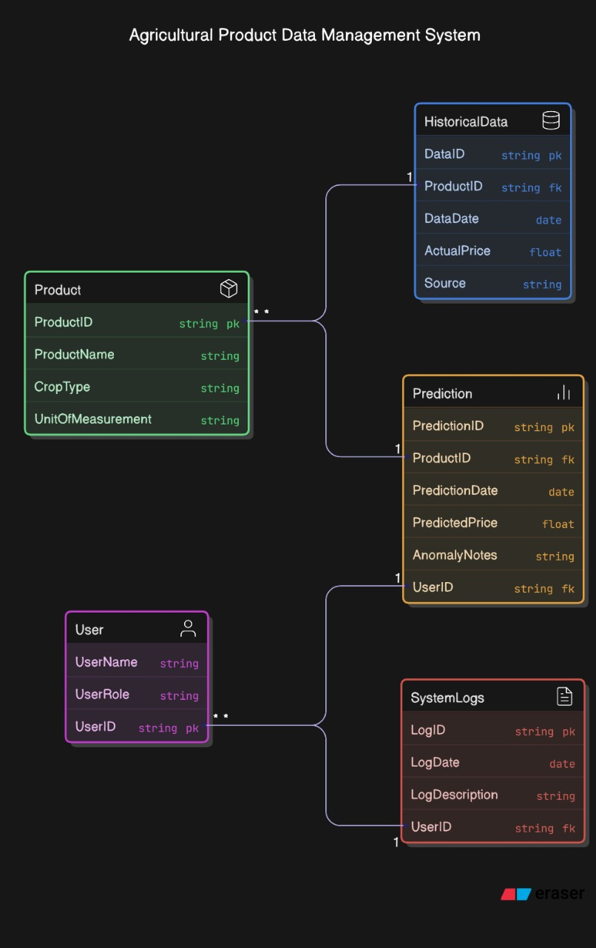

1. **SEQUENCE DIAGRAM**

1. **CLASS DIAGRAM**

1. **USE CASE DIAGRAM**

1. **ARCHITECTURE DIAGRAM**

